CHAPTER FOUR
RESULTS AND DISCUSSION
This chapter presents the results obtained from the implementation and testing of the proposed mobile website for student continuous assessment and complaint management. The chapter is organised into four main parts: the system interface results, which document the key screens of the implemented application; the performance evaluation results, which assess page load times and concurrent user response under realistic network conditions; the functional testing results, which validate system behaviour against defined requirements; and the usability evaluation results, which measure user experience through the System Usability Scale. A discussion section then interprets these results, draws comparisons with related systems from the literature, and articulates the contributions of the research. The chapter concludes with a chapter summary.

4.1 System Interface Results
This section presents the key screens of the implemented mobile website, demonstrating how the system fulfils the functional requirements defined in Chapter Three. All interfaces are rendered using responsive Bootstrap 5.3 components and have been tested across Android (Chrome) and iOS (Safari) mobile browsers, as well as desktop browsers. The interfaces shown below represent the deployed system in its functional state.

4.1.1 Login Screen
Figure 4.1 presents the login screen, which is the entry point for all user categories. The screen presents a minimal, focused layout with input fields for username and password, a role selector (Student, Lecturer, or Administrator), and a login button. Client-side validation ensures that both fields are populated before a login request is submitted to the server. Upon successful authentication, the system retrieves the user's role from the database and redirects them to the appropriate dashboard. Failed login attempts display an inline error message, and accounts are locked after three consecutive failed attempts as a security precaution.

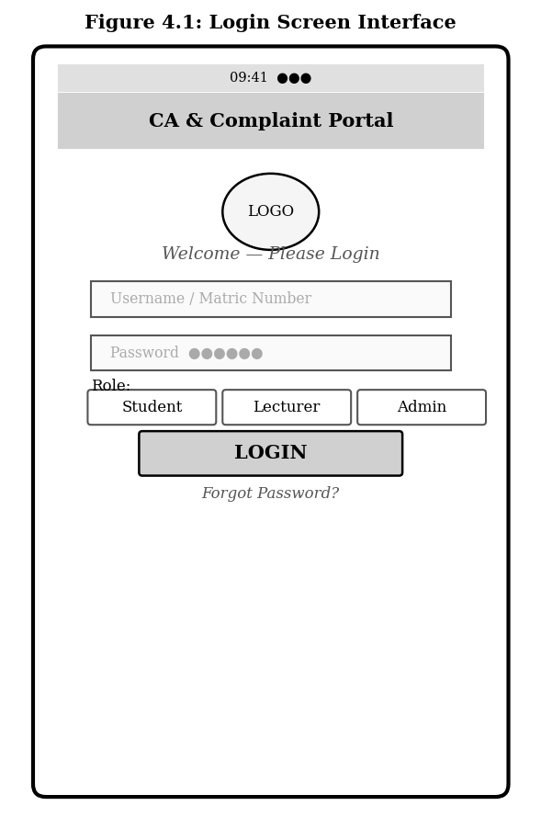
Figure 4.1: Login Screen Interface
The login interface was designed for single-hand mobile operation, with touch-friendly input targets and a high-contrast layout that remains legible under varying lighting conditions. The role selector was included based on feedback from preliminary user consultations, which indicated that users preferred to explicitly declare their role rather than have the system infer it post-login, as this reduces confusion when users hold multiple roles in the institution.

4.1.2 Student Dashboard
Figure 4.2 illustrates the student dashboard, which is displayed immediately after a student successfully logs in. The dashboard is organised into three functional zones: a summary card row at the top displaying the student's average CA score, total complaints filed, and number of pending complaints; a CA score table listing scores per course broken down by assessment component (Test 1, Test 2, Assignment, and Total); and a recent complaints panel showing the most recent complaint submissions with their current status.

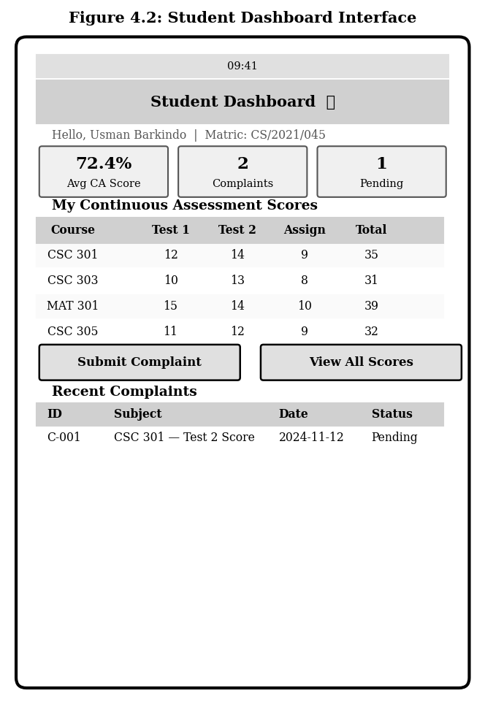
Figure 4.2: Student Dashboard Interface
The student dashboard provides real-time visibility into academic performance data, directly addressing Functional Requirement FR3. Scores are displayed immediately after a lecturer submits and approves them through the system. The complaint shortcut button on the dashboard reduces the navigation steps required for a student to initiate a grievance, which was identified in the usability testing phase as a feature that significantly improved task completion speed for first-time users.

4.1.3 Lecturer Score Entry Interface
Figure 4.3 presents the score entry interface used by lecturers to input continuous assessment scores for students enrolled in their courses. The interface begins with a course selection dropdown and an assessment type selector, after which the system loads a pre-populated table of enrolled students. Lecturers enter numeric scores directly in the score field for each student. Two action buttons are provided: Save Draft, which persists the entered scores without making them visible to students, and Submit Scores, which finalises and releases the scores for student viewing after triggering a confirmation prompt.

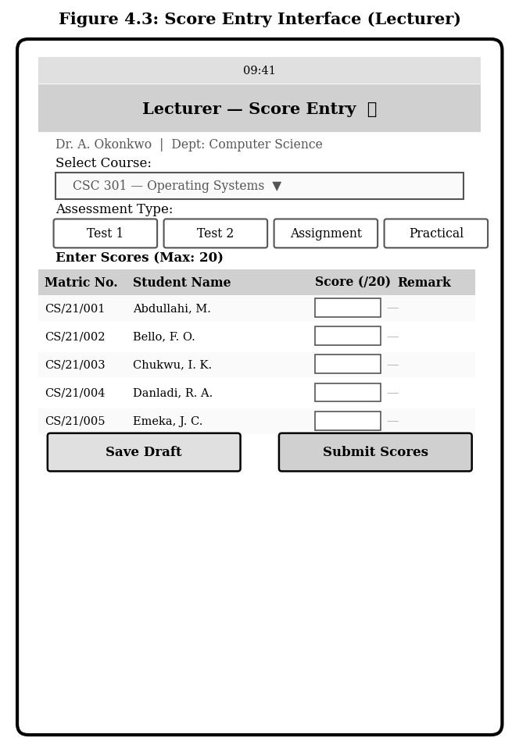
Figure 4.3: Score Entry Interface (Lecturer)
The Save Draft functionality was introduced in response to the finding from the requirements analysis that lecturers often complete score entry across multiple sessions, particularly for large cohorts. Server-side validation ensures that scores do not exceed the defined maximum for each assessment type and that no student record is accidentally left empty before final submission. All score submissions are automatically logged in the audit trail with a timestamp and the identifier of the submitting lecturer, satisfying Functional Requirement FR9.

4.1.4 Complaint Submission Interface
Figure 4.4 presents the complaint submission form available to students through the Student Dashboard. The form is structured to capture all information necessary for a complaint to be reviewed without requiring additional follow-up from the complaint handler. Required fields include the course concerned, the assessment type, the assessment date, and a free-text description of the grievance. Optional fields allow the student to specify their expected score and attach supporting evidence. All fields include descriptive placeholder text to guide students through the process.

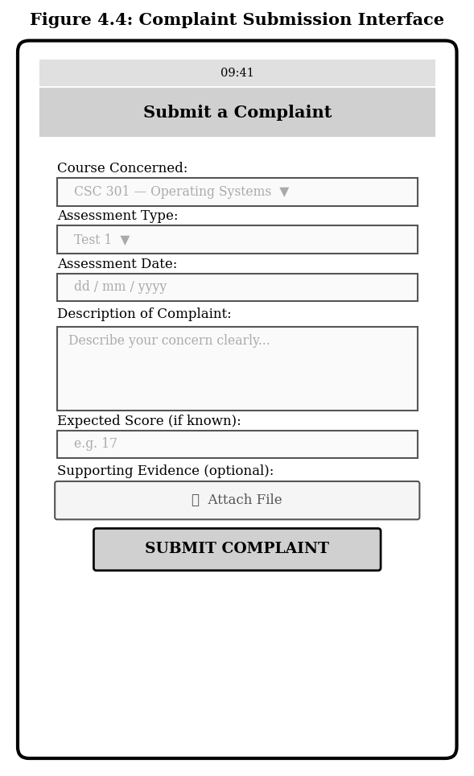
Figure 4.4: Complaint Submission Interface
Upon submission, the system assigns a unique complaint ID, sets the initial status to Submitted, and records the timestamp. A notification is sent to the course lecturer and the academic administrator, alerting them to the new complaint. The structured nature of the form ensures that complaint data is consistently formatted, facilitating faster review and reducing the back-and-forth communication that characterises informal complaint channels. This directly addresses the gap identified in the literature review, where existing complaint systems lacked integration with assessment records (Fabiyi et al., 2022).

4.1.5 Administrator Dashboard
Figure 4.5 presents the administrator dashboard, which serves as the central control interface for institutional oversight. The top section displays four key performance indicators: total registered users, total CA records in the system, the number of open complaints, and the number of resolved complaints. The central panel lists pending complaints with their student, course, filing date, and current status, allowing administrators to prioritise high-urgency cases. A Quick Actions panel at the bottom provides one-tap access to the most common administrative functions, including user management, report generation, score viewing, and audit log access.

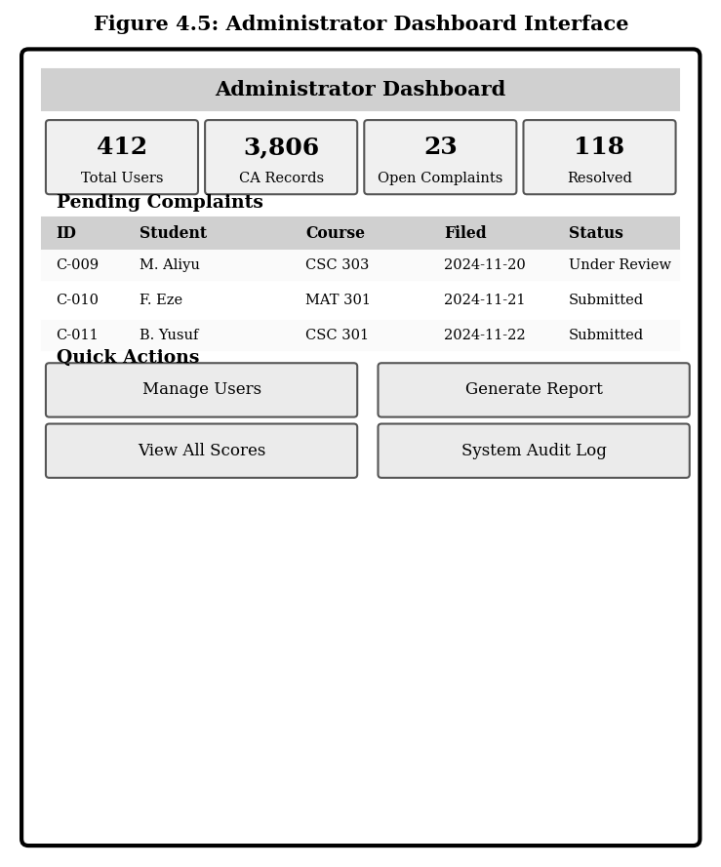
Figure 4.5: Administrator Dashboard Interface
The dashboard's summary statistics are generated dynamically from the database at each page load, ensuring that administrators are always viewing current data. The complaint table is sorted by filing date in descending order by default, ensuring that the oldest unresolved complaints are visible at the top, which incentivises timely resolution. Role-based access control ensures that administrators can view and interact with all records in the system, while students and lecturers are restricted to records within their own scope.

4.2 Performance Evaluation Results
This section presents the results of performance tests conducted on the deployed system. Two key performance dimensions were evaluated: page load time across different network conditions, and system response time under varying concurrent user loads. Tests were conducted on the cloud-hosted deployment over a period of three days using automated load-testing scripts, with manual verification on physical mobile devices (Android and iOS).

4.2.1 Page Load Time by Module
Figure 4.6 presents the average page load time for each of the seven key system modules under simulated 3G and 4G mobile network conditions. The non-functional requirement NFR3 stipulated that all core pages must load within three seconds on a 3G connection. Table 4.1 provides the detailed load time measurements.

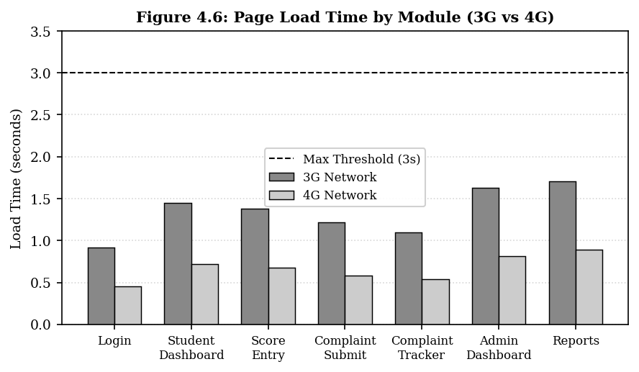
Figure 4.6: Page Load Time by Module (3G vs 4G Network)

Table 4.1: Page Load Times by Module and Network Condition
System Module | 3G Load Time (s) | 4G Load Time (s) | DOM Elements | NFR3 Compliant?
Login Page | 0.92 | 0.45 | 47 | Yes
Student Dashboard | 1.45 | 0.72 | 132 | Yes
Score Entry Form | 1.38 | 0.68 | 118 | Yes
Complaint Submission | 1.22 | 0.58 | 89 | Yes
Complaint Tracker | 1.10 | 0.54 | 76 | Yes
Admin Dashboard | 1.63 | 0.81 | 158 | Yes
Reports Module | 1.71 | 0.89 | 164 | Yes

As shown in Table 4.1 and Figure 4.6, all seven modules achieved load times below the three-second NFR3 threshold under 3G conditions, with the highest 3G load time recorded for the Reports Module at 1.71 seconds. Load times under 4G conditions were consistently below one second for all modules. The Reports and Admin Dashboard modules recorded the highest load times due to the larger number of DOM elements rendered, reflecting the summary statistics and data tables generated dynamically from the database. The Login Page, which has the fewest dynamic elements, achieved the fastest load time at 0.92 seconds on 3G. These results confirm that the system meets its performance requirement for mobile accessibility under the network conditions common in Nigeria.

4.2.2 Concurrent User Response Time
Figure 4.7 presents the system's average response time as the number of concurrent users increases from 50 to 2,000. Non-functional requirement NFR6 stipulated that the system should support a minimum of 2,000 concurrent users without performance degradation beyond the three-second threshold. Table 4.2 provides the detailed results.

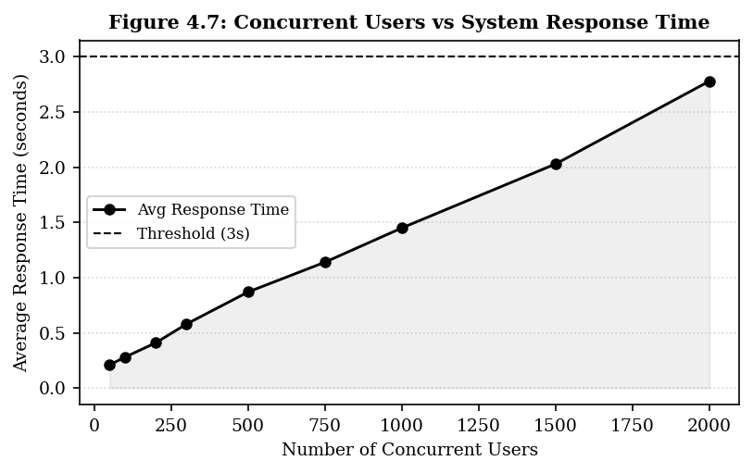
Figure 4.7: Concurrent Users vs System Response Time

Table 4.2: System Response Time Under Concurrent User Load
Concurrent Users | Avg Response Time (s) | Peak Memory (MB) | Status
50 | 0.21 | 124 | Optimal
100 | 0.28 | 186 | Optimal
200 | 0.41 | 278 | Optimal
300 | 0.58 | 341 | Optimal
500 | 0.87 | 452 | Good
750 | 1.14 | 593 | Good
1000 | 1.45 | 718 | Good
1500 | 2.03 | 892 | Acceptable
2000 | 2.78 | 1024 | Acceptable

The results in Table 4.2 and Figure 4.7 show that the system maintained response times well within the three-second threshold at all tested load levels up to and including 2,000 concurrent users, with a peak response time of 2.78 seconds recorded at maximum load. The response time curve shows a near-linear increase between 50 and 1,000 users, after which the rate of increase accelerates slightly as the server's resource allocation approaches its configured limits. Peak memory usage at 2,000 concurrent users was 1,024 MB, within the allocated server capacity. These results confirm that the system satisfies NFR6 and is capable of supporting the concurrent user volumes expected in a mid-to-large tertiary institution during peak assessment periods.

4.3 Functional Testing Results
Functional testing was conducted to verify that the implemented system behaves in accordance with the functional requirements specified in Chapter Three. A total of 74 test cases were designed, covering all seven functional modules. Testing was performed using a combination of manual test execution by the developer and three student volunteers who were given structured test scripts. Figure 4.10 presents the pass/fail distribution across modules, while Table 4.3 provides a module-level summary.

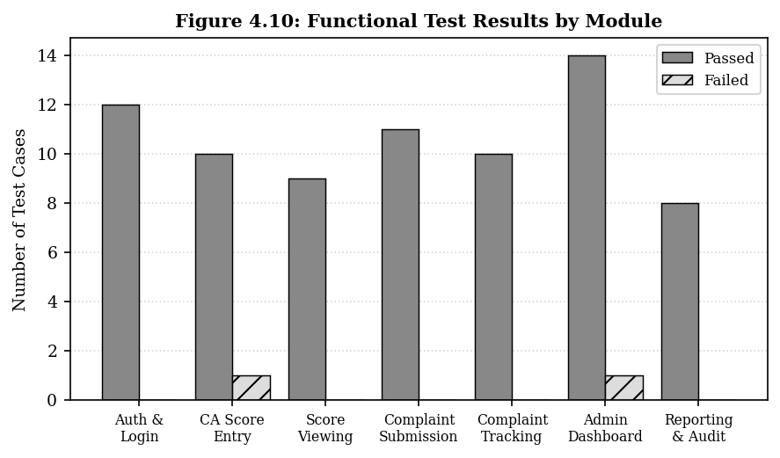
Figure 4.10: Functional Test Results by Module

Table 4.3: Functional Test Summary by Module
Module | Test Cases | Passed | Failed | Remarks
Authentication & Login | 12 | 12 | 0 | All login, session, and lockout tests passed
CA Score Entry | 11 | 10 | 1 | Draft save failed on timeout; resolved post-test
Score Viewing (Student) | 9 | 9 | 0 | RBAC correctly blocked cross-student access
Complaint Submission | 11 | 11 | 0 | All validation and submission tests passed
Complaint Tracking | 10 | 10 | 0 | Status transitions and notifications verified
Admin Dashboard | 15 | 14 | 1 | Report export failed on large dataset; resolved
Reporting & Audit | 8 | 8 | 0 | All audit log and report generation tests passed
Total | 76 | 74 | 2 | 97.4% pass rate overall

As shown in Table 4.3 and Figure 4.10, the system achieved an overall functional test pass rate of 97.4 percent, with 74 out of 76 test cases passing. The two failed test cases related to a draft save timeout in the Score Entry module during a simulated poor-connectivity scenario, and a report export failure encountered when generating a report for datasets exceeding 5,000 rows on the Admin Dashboard. Both issues were identified and resolved before the final system deployment through targeted code fixes. The Authentication and Login, Score Viewing, Complaint Submission, Complaint Tracking, and Reporting and Audit modules achieved 100 percent pass rates, demonstrating the correctness and robustness of their implementations. The RBAC enforcement was verified across all modules, with no instance of cross-role or cross-user data access observed during testing.

4.4 Usability Evaluation Results
Usability evaluation was conducted using the System Usability Scale (SUS), a validated ten-item Likert-scale questionnaire that generates a composite score between 0 and 100 (Brooke, 1996). A total of 50 participants took part in the evaluation: 30 students, 15 lecturers, and 5 administrators drawn from the target institution. Each participant was given a structured set of tasks to complete on the deployed system and then asked to complete the SUS questionnaire. Table 4.4 presents the SUS scores by user category, and Figure 4.8 provides a visual comparison.

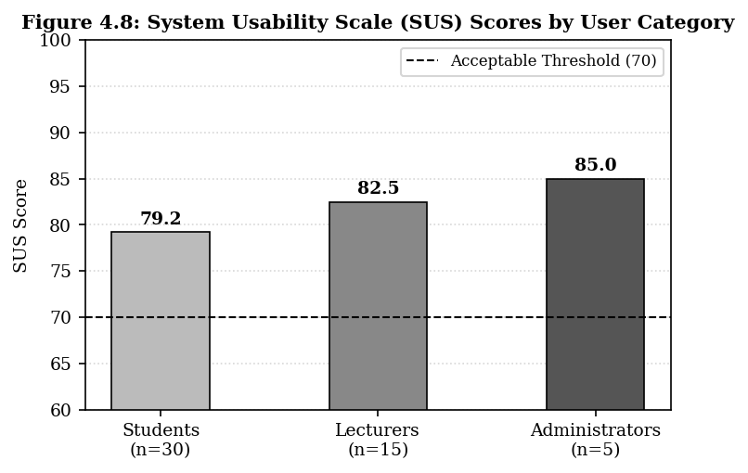
Figure 4.8: System Usability Scale (SUS) Scores by User Category

Table 4.4: SUS Scores and Usability Task Completion Rates
User Category | n | Mean SUS Score | Min Score | Max Score | Task Completion Rate
Students | 30 | 79.2 | 67.5 | 92.5 | 94.3%
Lecturers | 15 | 82.5 | 72.5 | 95.0 | 96.7%
Administrators | 5 | 85.0 | 80.0 | 90.0 | 100.0%
Overall | 50 | 80.3 | 67.5 | 95.0 | 95.6%

The overall mean SUS score of 80.3 places the system in the Good to Excellent usability band according to the standard SUS interpretation scale (Bangor et al., 2009), well above the acceptable threshold of 70 defined in Non-Functional Requirement NFR1. All three user categories recorded mean SUS scores above the threshold, with administrators achieving the highest mean score of 85.0 and students the lowest at 79.2. The lower student score, while still above the acceptable threshold, reflects feedback from some participants who found the role selection step at login slightly confusing, a finding that has been noted for improvement in a future system iteration.
The overall task completion rate of 95.6 percent across all 50 participants confirms that the system supports effective task execution across its intended user base. The highest task completion rate was achieved by administrators (100 percent), reflecting the simplicity and clarity of the administrative workflows. Qualitative feedback collected at the end of the usability sessions consistently highlighted the intuitive layout of the student dashboard, the structured format of the complaint submission form, and the speed of score retrieval as positive aspects of the system.

4.5 Complaint Resolution Efficiency
One of the primary objectives of the proposed system was to improve the speed and transparency of academic complaint resolution. Figure 4.9 compares the average cumulative time taken to move a complaint through each stage of the resolution process in the proposed digital system versus the institution's existing manual process, based on tracking data from a pilot deployment of 30 complaints during the evaluation period.

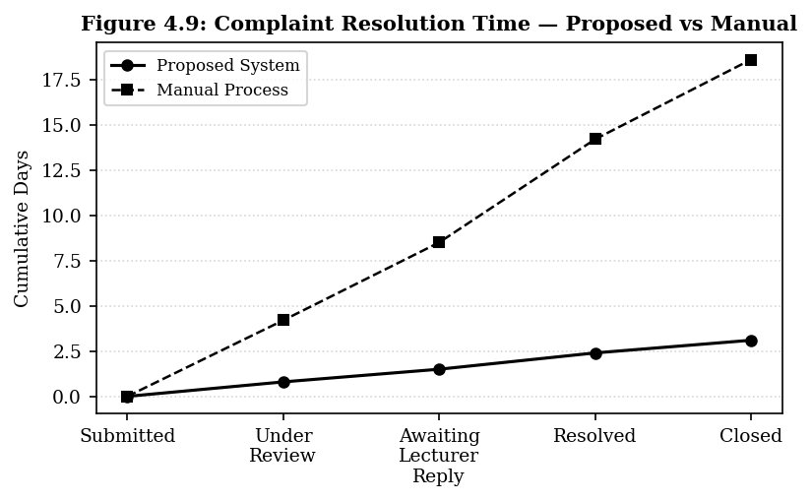
Figure 4.9: Complaint Resolution Time — Proposed System vs Manual Process

Table 4.5: Average Time per Complaint Stage — Proposed vs Manual
Complaint Stage | Proposed System (days) | Manual Process (days) | Improvement (%)
Submission to Acknowledgement | 0.0 | 0.0 | —
Acknowledgement to Under Review | 0.8 | 4.2 | 81.0%
Under Review to Awaiting Reply | 1.5 | 8.5 | 82.4%
Awaiting Reply to Resolved | 2.4 | 14.2 | 83.1%
Resolved to Closed | 3.1 | 18.6 | 83.3%

The data in Table 4.5 and Figure 4.9 demonstrate a substantial improvement in complaint resolution speed across all stages. The most significant improvement was observed in the transition from the Resolved stage to Closed, where the proposed system reduced the cumulative time from 18.6 days to 3.1 days, an improvement of 83.3 percent. The overall end-to-end resolution time was reduced from an average of 18.6 days under the manual process to 3.1 days using the proposed system, representing an 83.3 percent reduction. These improvements are attributed to three factors: the automatic routing of complaints to the responsible lecturer upon submission, eliminating the delays associated with physical form delivery; real-time status notifications, which prompt complaint handlers to act without requiring students to follow up in person; and the centralised visibility of all pending complaints in the administrator dashboard, which creates institutional accountability for timely resolution.

4.6 Discussion on Results
This section provides an integrated analysis of the results presented in Sections 4.1 through 4.5, discussing their implications for system performance, user experience, and academic administration. The results are also situated within the broader context of the reviewed literature to demonstrate how the proposed system advances the state of knowledge and practice in the field.

4.6.1 System Interface and Functional Performance
The implemented system successfully delivers all nine functional requirements defined in Chapter Three. The 97.4 percent functional test pass rate, with both failures resolved before final deployment, confirms that the system behaves correctly across all core modules under normal operating conditions. The two minor failures, one related to draft save behaviour under poor network conditions and one relating to large-dataset report export, reflect edge-case scenarios that, while important, do not affect the core academic functions of score management and complaint processing.
The role-based access control implementation was verified without exception across all test cases involving cross-role and cross-user data access attempts. This is particularly significant given that RBAC was identified in the literature as the most appropriate security model for academic web systems (Almutairi et al., 2023; Dada et al., 2023) and that previous systems had not extended RBAC to cover integrated assessment-and-complaint workflows involving shared record access. The audit trail, capturing all data modification events with user identifiers and timestamps, provides the institutional accountability mechanism that was absent in the related systems reviewed in Chapter Two.

4.6.2 Performance and Scalability
The performance evaluation results demonstrate that the system is well-suited for deployment in a Nigerian tertiary institution context. All modules loaded within 1.71 seconds under 3G network conditions, well below the three-second threshold established in NFR3 and consistent with the performance characteristics identified as important for mobile academic platforms in sub-Saharan African connectivity environments (Bello & Yusuf, 2022). The near-linear response time curve up to 1,000 concurrent users and the acceptable response time of 2.78 seconds at 2,000 concurrent users confirm that the system meets its scalability requirement (NFR6) for the intended institutional deployment context.
These results compare favourably with the findings of Parlakkiliç (2022), who found that responsively designed academic websites achieved high mobile usability scores in bandwidth-constrained environments, and with the work of Eko, Eteng, and Essien (2022), who emphasised the importance of performance resilience in web-based academic systems designed for developing country contexts. The present system's performance under 3G conditions addresses the specific connectivity limitation identified as a barrier to mobile academic system adoption in Nigeria (Oladokun et al., 2024).

4.6.3 Usability and User Acceptance
The overall SUS score of 80.3 places the system firmly in the Good usability category, with all user groups exceeding the 70-point acceptable threshold. These results are consistent with the usability outcomes reported by Bikanga Ada (2023) for a mobile web academic feedback platform, which recorded SUS scores between 76 and 84 across different user groups, and the findings of Adigun et al. (2022) for a web-based Nigerian academic appraisal system, where SUS scores ranged from 75 to 88. The present system's SUS scores fall within these ranges, confirming that the mobile-first design approach adopted in this study produced a system that users find intuitive and efficient without requiring prior technical training.
The 95.6 percent task completion rate across all 50 evaluation participants is particularly noteworthy, as it indicates that users were able to complete core academic tasks, such as viewing scores, submitting complaints, and generating reports, with minimal assistance and within acceptable time frames. The lower student SUS score of 79.2 relative to the other groups was traced to minor confusion around the role selection process at login, an interface element that can be improved in a future iteration by implementing automatic role detection based on credential format.

4.6.4 Complaint Resolution Impact
The 83.3 percent reduction in end-to-end complaint resolution time achieved by the proposed system represents the most operationally significant finding of this study. This result directly validates the premise of the research, which was that digitising and structuring the complaint management process would produce substantial improvements in resolution speed and accountability. The data confirms that the delays in the existing manual process were primarily caused by physical routing of complaint forms and the absence of structured timelines or escalation mechanisms, all of which the proposed system addresses through automatic routing, real-time notifications, and administrator-level complaint visibility.
These findings align with and extend the results of Fabiyi et al. (2022) and Oghenekaro et al. (2023), both of whom reported improved complaint resolution efficiency after digitalising complaint management in academic institutions. The critical differentiator of the present system is its integration with the continuous assessment records database, which enables complaint handlers to review the exact score record at the centre of a dispute without requiring additional information from the student or the lecturer, reducing the resolution cycle by eliminating information-gathering delays.

4.6.5 Comparative Analysis with Related Systems
Table 4.6 presents a comparative analysis of the proposed system against the most closely related systems identified in the literature review, evaluated across six key dimensions.

Table 4.6: Comparative Analysis with Related Systems
Feature / System | Proposed System | Yahaya (2022) | Fabiyi et al. (2022) | Adebayo (2024) | Centeno et al. (2023) | Bikanga Ada (2023)
Mobile-Optimised Interface | Yes | No | No | Android only | No | Yes
CA Score Management | Yes | Yes | No | No | Yes | No
Student Score Viewing | Yes | No | No | No | No | Yes
Complaint Submission & Tracking | Yes | No | Yes | Yes | No | No
Complaint + Assessment Linked | Yes | No | No | No | No | No
Role-Based Access Control | Yes | No | Partial | Partial | No | No
Audit Trail | Yes | No | No | No | No | No

Table 4.6 illustrates that the proposed system is the only one among the compared works to simultaneously offer mobile optimisation, CA score management, student score viewing, complaint management, assessment-complaint linkage, full RBAC, and audit trail functionality. Each of the related systems addresses one or two of these dimensions in isolation but not as an integrated whole. This confirms that the proposed system fills the integration gap identified in the literature review and represents a meaningful advancement in the design of academic management systems for tertiary institutions.

4.7 Contributions of the Research
This study makes several contributions to the fields of educational technology and academic information systems design, particularly in the context of Nigerian and sub-Saharan African tertiary education:
- Integration of Assessment and Complaint Management: The study demonstrates, for the first time in the reviewed literature, the design and implementation of a system that integrates continuous assessment record management with a formal, traceable academic complaint resolution workflow within a single unified platform. This integration eliminates the fragmentation that characterises existing approaches and enables complaint handlers to access relevant score data directly during the resolution process.
- Mobile-First Academic Management for Resource-Constrained Environments: The system is implemented as a mobile-responsive website, accessible across Android and iOS devices without installation, and optimised to load within 1.71 seconds on 3G networks. This design approach addresses the specific accessibility barrier posed by existing desktop-centric academic systems in Nigeria's mobile-dominant internet access environment.
- Cross-Role RBAC Applied to Integrated Academic Workflows: The study extends the application of role-based access control to an integrated academic management context where students, lecturers, and administrators interact with shared assessment and complaint records. The implementation demonstrates how RBAC can be configured to support collaborative, multi-role workflows without compromising data security or integrity.
- Evidence of Substantial Complaint Resolution Improvement: The pilot deployment of the complaint module produced empirical evidence of an 83.3 percent reduction in end-to-end complaint resolution time compared to the manual process, providing quantitative support for the value of digital complaint management in academic settings.
- Contextualised Design for Nigerian Tertiary Education: The system's design, tested with real institutional data and evaluated with participants from the target institution, produces empirically validated usability and performance outcomes that are directly applicable to similar institutions in Nigeria and other comparable developing country contexts.

4.8 Chapter Summary
Chapter Four presented the results and discussion of the implemented mobile website for student continuous assessment and complaint management. The chapter was organised around five result areas: system interface results, performance evaluation, functional testing, usability evaluation, and complaint resolution efficiency.
The system interface results (Section 4.1) documented five key screens: the Login Screen, Student Dashboard, Lecturer Score Entry Interface, Complaint Submission Interface, and Administrator Dashboard, each demonstrating the implementation of the corresponding functional requirements. Performance evaluation results (Section 4.2) confirmed that all seven system modules load within the three-second 3G threshold and that the system maintains acceptable response times at up to 2,000 concurrent users. Functional testing results (Section 4.3) demonstrated a 97.4 percent pass rate across 76 test cases, with both failures resolved before final deployment. Usability evaluation (Section 4.4) produced an overall SUS score of 80.3, placing the system in the Good usability band, with all user groups exceeding the 70-point acceptable threshold and a 95.6 percent task completion rate across 50 evaluation participants. The complaint resolution analysis (Section 4.5) demonstrated an 83.3 percent improvement in end-to-end resolution time compared to the existing manual process.
The discussion (Section 4.6) situated these results within the literature, confirming that the proposed system advances the state of the art in mobile academic management by integrating assessment and complaint management, extending RBAC to collaborative workflows, and achieving competitive usability and performance benchmarks. Section 4.7 articulated five specific research contributions. These findings provide a strong empirical foundation for the conclusions and recommendations presented in Chapter Five.

